Name:__________________________________________________ Period: ______

2025-2026 Honors Physics 514 Midterm Exam


LaSalle College High School Mr. Werman
Time: 90 Minutes December 2025

Gentlemen,

The exam consists of two parts: Multiple Choice (50%) and Free Response (50%). The Multiple-Choice section has 15 “Conceptual” questions (1 points each) and 10 “Calculation” questions (3 points each). Your answers are to be recorded on the Scantron sheet provided. You may use the space provided for written work, but no partial credit will be rewarded for the multiple-choice questions. The Free Response portion consists of five questions with point totals listed for each problem. Take your time while working on the exam and be sure to check your work. For pacing, you should allot about 45 minutes for each part of the exam. Good luck!

General Directions:
1. Place your name and class period on all materials.
2. Show ALL work for free response questions in the space provided or on scrap paper
3. Read the directions carefully and pace yourself appropriately.
4. You may detach the formula sheet from this packet
5. Staple any work on scrap paper to your test and label with the appropriate problem number.

Student Honor Code
A student’s acceptance of enrollment in La Salle College High School and continuation of enrollment in La Salle are contingent upon the student’s acceptance of and adherence to the principles of this Student Honor Code.

RESPONSIBILITIES OF STUDENTS:
- To complete all academic work honestly and independently.
- To refrain from revealing any information regarding the contents of a test, directly or indirectly, to any other student who may subsequently take the same test.
- To refrain from unethical use of computers and/or cellphones.
- To refrain from personal dishonesty as more fully defined in this Honor Code.

Name:__________________________________________________ Period: ______

Multiple Choice I (Conceptual): Mark the letter of the best answer on the Scantron sheet. (2 points each)

1. The distance traveled by an object is always _____________________________ its displacement.
- Greater than or equal to
- Less than or equal to
- Greater than
- Less than

2. The slope at any point along the line of a position vs time graph represents what quantity?
a) acceleration c) elapsed time
b) displacement d) velocity
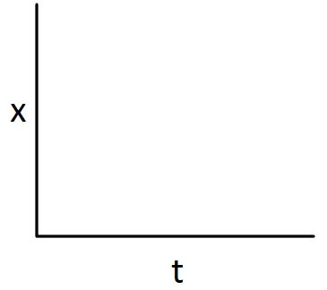



3. Which of the following Position vs Time graphs would best describe a car moving in the negative direction and speeding up?

a) b) c) d)

4. Which statement is TRUE based on the Velocity vs Time graph shown below:
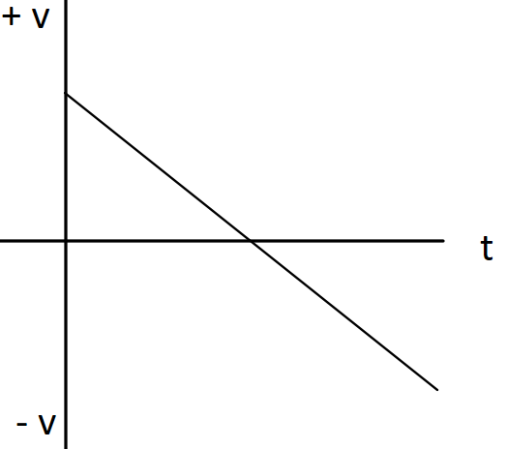
a) The object starts with a negative velocity.
b) The object has a constant velocity.
c) The acceleration is changing.
d) The object changes direction.

5. An object moving in the +x direction experiences an acceleration of -2.0 m/s². This means the object
a. travels 2.0 m in every second.
b. is traveling at 2.0 m/s.
c. is decreasing its velocity by 2.0 m/s every second.
d. is increasing its velocity by 2.0 m/s every second.

6. When a car’s velocity is negative and its acceleration is negative, what is happening to the car’s motion?
a) the car slows down
b) the car speeds up
c) the car travels at constant speed
d) the car remains at rest

7. When a ball is thrown straight up and with no air resistance, the acceleration at its highest point
a) is upward.
b) reverses from upward to downward.
c) is downward.
d) is zero.

8. Jimmy and Ryan dive from a cliff overhang into a lake below. Jimmy simply drops straight down from the edge. Ryan takes a running start and jumps out horizontally with an initial velocity of 5 m/s. When they reach the lake below…
a) they will be the same distance away from the cliff.
b) the speed of Jimmy is greater than that of Ryan.
c) they will both have the same speed.
d) they will have been in the air for the same amount of time.

9. The impulse experienced by an object is the same as the object’s change in:
a) velocity c) momentum
b) acceleration d) mass

10. A constant unbalanced force acts on an object. Describe the motion of the object.
a) constant acceleration
b) constant speed
c) constant velocity
d) increasing acceleration

11. A player catches a ball. Consider the impact force of the ball against the player's glove. What is the 3rd Law force pair?
a) The muscular effort in the player's arms
b) The force the glove exerts on the ball
c) Friction of the ground against the player's shoes
d) The player's grip on the glove

12. For a ball in freefall, what is the 3rd Law force paired with the gravitational pull of the earth's mass on the ball?
- There is no reaction force in this case
- Air resistance acting against the ball
- The gravitational pull of the ball's mass on the earth
- The normal force of the earth on the ball

13. Which of the following scenarios BEST describes an object that is accelerating?
a. A bicyclist coasting on a flat road.
b. A bicyclist slowing down as it approaches an intersection.
c. A bicyclist coasting on a flat road after traveling down a large hill.
d. A bicyclist pedaling up a hill to maintain its speed.

14. A car is driving East when the driver removes his foot from the gas pedal and applies the brakes to bring the car to a stop. Which of the following would represent the free‐body diagram of the car during the braking period?
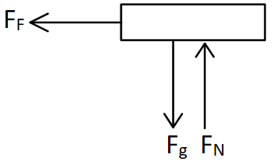
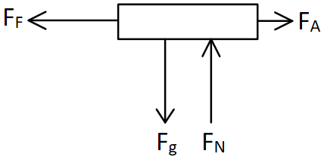
a) c)

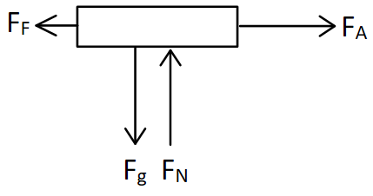
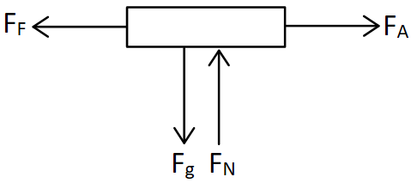
b) d)

15. The normal force on an object always acts in which direction?
a) opposite to gravity
b) perpendicular to the surface
c) upwards
d) parallel to the surface

Multiple Choice II (Calculations): Mark the letter of the best answer on the Scantron sheet. (3 points each)
16. Convert 34 $\frac{kg*m^{3}}{hr} to \frac{lb*ft^{3}}{min}$ (Note: 1 lb = 0.45 kg; 1 m = 3.28 ft)
a) 44.4 $\frac{lb*ft^{3}}{min}$ c) 159,970 $\frac{lb*ft^{3}}{min}$
b) 4.1 $\frac{lb*ft^{3}}{min}$ d) 1.3 $\frac{lb*ft^{3}}{min}$

17. A train starts 100 miles East of Philadelphia traveling West at an average speed of 65 mph. How long is the train ride if the destination is 230 miles West of Philadelphia?
a) 3.54 hours c) 0.20 hours
b) 2 hours d) 5.08 hours

18. A 3000 kg car traveling 15 m/s East collides head-on with a 1000 kg car heading at the same speed West. What is the magnitude of the momentum of the system before the collision?
a) 30,000 kg*m/s
b) 60,000 kg*m/s
c) 45,000 kg*m/s
d) 15,000 kg*m/s

19. A car with a mass of 1200 kg is traveling at 20 m/s when it strikes a 75 kg bicyclist traveling in the same direction at 12 m/s. After the collision, the car is traveling at 18 m/s. How fast is the bicyclist now going?
a) 20 m/s
b) 28 m/s
c) 36.9 m/s
d) 44 m/s

20. For a physics mini-lab, a student measures the time for a fan cart to travel from the 18 cm mark on a ruler to the 96 cm mark (starting from rest). Over three trials, the average time is measured to be 2.48 s. What is the fan cart’s acceleration?
a) 12.68 cm/s²
b) 25.36 cm/s²
c) 31.45 cm/s²
d) 37.07 cm/s²

21. A frustrated Phillies fan throws an opposing team’s homerun ball back onto the field. The throw leaves the hand with a speed of 8 m/s and angle of 35$°$ above horizontal. How far away (horizontally) will the ball land if it remains in the air for 2.5 s?
a) 11.5 m c) 20 m
b) 16.4 m d) 14 m

22. A ball thrown horizontally at 20 m/s from the roof of a building lands 48 m from the base of the building. How high is the building?
a) 28.2 m c) 0.85 m
b) 11.8 m d) 19.8 m

23. A model rocket powered toy car with a mass of 0.062 kg is launched from rest along a flat frictionless surface. The motor applies a constant force of 2.65 N to propel the rocket car to a velocity of 31 m/s before the engine cuts off. If drag is ignored, how long did the engine fire?
a) 0.725 s c) 0.085 s
b) 1.92 s d) 0.941 s

24. A falling bungee jumper with a mass of 75 kg begins to slow with an acceleration of 4 m/s² as the bungee cord stretches. What is the force in the cord? (Ignore air resistance)
a) 1035 N c) 735 N
b) 300 N d) 375 N

25. A 130 N box accelerates across a carpeted floor at 2 m/s² when pushed with a horizontal applied force of 60 N. How much friction acts on the box?
a) 130 N c) 26.5 N
b) 33.5 N d) 86.5 N

Name:__________________________________________________ Period: ______

FREE RESPONSE

SHOW ALL WORK to receive full credit. Write your answer on the line provided and be sure to include proper UNITS.

1. Clark is testing a new rocket-powered sled. The engine provides 80 N of thrust, and Clark with the sled have a combined weight of 900 N. He starts from rest at the top of a 30° snowy hill that has a kinetic coefficient of friction between the sled and the snow of 0.15. Clark fires the engine and travels 35 meters before reaching the bottom of the hill.
a) Draw the FBD of Clark (with his sled).
b) Sketch the Position vs Time and Velocity vs Time graphs for the motion along the hill.
c) How fast is he traveling when he reaches the bottom? _______________

FBD

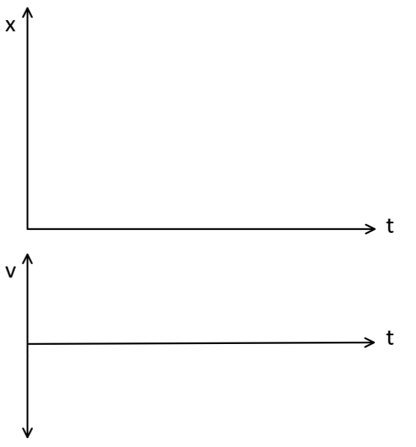
2. Mr. Werman sets up a head-on collision between two Carts. Cart A is a 0.5 kg fan cart starting from rest at a position of 0 m. The fan applies a 0.6 N force to produce a uniform acceleration (friction/drag is negligible). Cart B (4.8 kg) starts at the +1.80 m mark moving with a constant speed of 0.40 m/s towards Cart A. After the collision, the carts stick together, the fan stops pushing, and the carts continue moving along the frictionless surface. (15 Points)

a) Where on the track will the carts collide? _______________
b) What is the velocity of the carts after the collision? ____________
c) Sketch the Position vs Time and Velocity vs Time graphs for each Cart before and after they collide. The dotted line represents the time of the collision. (LABEL THEM!!)



3. A 58 g Estes model rocket is launched on Meehan field. The rocket motor is rated with an impulse of 2.5 N-s and fires for 0.5 s during the thrust phase of the flight. After the engine fires, the rocket continues in a coast phase to apogee. Assume a constant drag force of 0.2 N during the full ascent and ignore any changes in mass due to the engine firing. (15 Points)

a) Draw the FBDs of the rocket during the thrust and coast phases of the launch.
b) Sketch the Position vs Time and Velocity vs Time graphs for the rocket during its full ascent to apogee (peak).
c) Calculate the maximum altitude of the flight? _______________
Thrust FBD Coast FBD



4. A second rocket with a mass of 30 g reaches a peak of 120 m. On the descent, the rocket’s streamer fails to deploy, and the rocket accelerates with the nosecone intact to a terminal speed of 25 m/s (assume constant 0.1 N of drag for the accelerating portion). Once at terminal speed, it continues to the ground. (15 Points)

a) Draw the FBDs of the rocket during the accelerating descent and terminal descent phases.
b) Sketch the Position vs Time and Velocity vs Time graphs for the rocket during its full descent to the ground.
c) What was the total time to the ground from the peak? _______________
Accelerating Descent Terminal Descent
FBD FBD



